The importance of well yield in groundwater demand specification

Taro Mieno[1], Mani Rouhi Rad[2], Jordan F. Suter[3] and R. Aaron Hrozencik[4]

Abstract: The implementation of effective resource management policies critically depends on accurate estimates of the price elasticity of resource demand. In the case of groundwater, previous research estimating well-level groundwater demand has largely ignored the importance of well yield, which is a physical limit on the rate of groundwater extraction. In this research, we empirically estimate the price elasticity of demand for groundwater using well-level data from Colorado. Our results demonstrate that when well yield is omitted, price elasticity is overestimated. This in turn creates inaccurate predictions of the effect of price-based conservation policies on groundwater use and welfare impacts.

# Introduction

Groundwater resources are an essential water supply source for irrigation in arid areas and declining aquifer levels represent a significant threat to agricultural production in many parts of the world. In the face of continued aquifer depletion, producers and policy-makers have considered a range of different policies for managing groundwater use over time (OECD 2016; Smith et al. 2017; Hoogesteger and Wester 2017; R. Hrozencik et al. 2017; Drysdale and Hendricks 2018). Designing groundwater management policies to achieve desired conservation objectives requires an accurate understanding of the incentives that determine groundwater use behavior. Most economic models of groundwater demand focus on economic variables that impact the benefits and costs associated with withdrawing groundwater at specific locations. In particular, increases in the marginal cost of groundwater use due to higher pumping costs are assumed to cause reductions in the quantity of groundwater demand. Changes in costs can impact groundwater use decisions of individual irrigators, however, changes in physical constraints on groundwater pumping also play an important role in groundwater use outcomes (Timothy Foster, Brozović, and Butler 2014; R. Hrozencik et al. 2017). In this paper, we illustrate the importance of accounting for well yield (also referred to as well capacity), a real-time constraint on groundwater pumping determined by the physical properties of the groundwater system, in predicting changes in groundwater use. We show that ignoring well yield not only leads to inaccurate predictions of groundwater use, but also has a dramatic effect on the reliability of estimates of the price elasticity of demand for groundwater. Accounting for well yield is therefore essential for designing groundwater management policies to achieve desired objectives and for measuring welfare impacts.

A limited set of recent research recognizes the important impact of well yield on irrigation decisions (Timothy Foster, Brozović, and Butler 2014; T. Foster, Brozović, and Butler 2015; Rouhi Rad et al. 2020). Well yield refers to the maximum rate at which groundwater can be extracted from a well, typically expressed in gallons per minute (GPM) and represents a constraint on the instantaneous amount of water that can be extracted. For a given pumping cost, a lower well yield means that the instantaneous amount of groundwater that a farmer can extract during the growing season is lower. Even with low well yield, the total volume of water that can be extracted from a well during a growing season may be larger than the seasonal water demand of the crop grown on a parcel. However, with low well yield a farmer may not be able to meet crop water demand during the critical stages of the growing season, especially during dry years, which can result in reduced crop yields (Rouhi Rad et al. 2020).

Recent studies show that low well yields can affect profits directly, independent of pumping costs (Rouhi Rad et al. 2020; Timothy Foster, Brozović, and Butler 2014; T. Foster, Brozović, and Butler 2015). Well yield at a given location is a function of the saturated thickness of the aquifer, as well as time-invariant physical aquifer characteristics. Groundwater pumping in excess of recharge leads to declines in saturated thickness over time, which causes well yield to decrease. Lower well yield has been shown to result in fewer irrigated acres, less water applied per acre conditional on irrigated acres, and a transition to less water-intensive crops (Rouhi Rad, Araya, and Zambreski 2020; Timothy Foster, Brozović, and Butler 2014). Declines in saturated thickness also cause pumping costs to increase, because the distance that groundwater must be lifted to the surface elevation increases as saturated thickness declines. As a result, changes in well yield and pumping costs are correlated over time for a given well.

Despite the importance of well yield in determining groundwater use and its correlation with pumping costs, past studies evaluating groundwater demand (Frank and Beattie 1979; M. Nieswiadomy 1985; Ogg and Gollehon 1989; Moore, Gollehon, and Carey 1994; Schoengold, Sunding, and Moreno 2006; Gonzalez-Alvarez, Keeler, and Mullen 2006; Wheeler et al. 2008; Hendricks and Peterson 2012; Pfeiffer and Lin 2014; Mieno and Brozović 2016; Smith et al. 2017; Kornelis 2018) have typically ignored well yield. The econometric consequence of omitting an important variable in a regression analysis is straightforward: coefficient estimation for covariates that are correlated with the omitted variable are biased. The previous studies are likely to have overstated the importance of pumping costs by attributing observed changes in groundwater use solely to changes in the marginal costs of groundwater pumping.

The bias introduced to price elasticity estimates by the omission of well yield has important implications for groundwater management policy-making. Accurate estimates of the price elasticity of demand are critical for assessing the welfare impacts associated with the implementation of groundwater management policies. For example, the estimated short-run welfare cost of an annual groundwater quantity restriction would appear to be smaller when producers are assumed to have a relatively elastic response to the marginal cost of groundwater use. Biased price elasticity estimates also present a challenge for the design of price-based management policies, which have attracted considerable attention from both economists and policy-makers (Tsur et al. 2004; Molle and Berkoff 2007; Sato 2011). Accurate price elasticity estimates allow policy-makers to design price-based policies which meet specific conservation and management objectives. To the extent that elasticity estimates are biased, this increases the likelihood that management policies generate outcomes that do not align with the original conservation or management objectives. As such, the potential for water pricing to achieve desired groundwater conservation objectives critically depends on an accurate understanding of the responsiveness of producers to changes in the cost of groundwater use.

Agricultural producers in the San Luis Valley of Colorado recently self-imposed water taxes to reduce groundwater extraction (Smith et al. 2017). The tax was shown to have substantially reduced groundwater use for irrigation within the region when initially implemented, although drought conditions in recent years have resulted in increased groundwater use (Rolph 2018). The implementation of the tax shows that producers can support self-imposed groundwater pricing, which suggests that carefully thought-out water taxes may be implementable elsewhere, such as other states overlying the High Plains Aquifer and parts of California that rely on groundwater resources. To this end, Nebraska has recently introduced legislation that calls for taxing groundwater extraction for agricultural production, although the main motivation for the legislation is to raise revenue. The revenue implications of such a water tax also critically dependent on the price elasticity of demand. Accurate estimates of the price elasticity of demand are also important for assessing the welfare impacts associated with the implementation of groundwater management policies.

The main goal of this paper is to understand how the omission of well yield impacts the accuracy of groundwater use predictions and generates bias in coefficient estimates. First, we theoretically investigate the impact of changes in well yield on groundwater use and the expected direction of bias on the coefficient estimate on irrigation costs (price elasticity of demand) when well yield is omitted from groundwater demand models. We then empirically test the theoretical exposition using groundwater use data from Colorado, where well yield is observed at the well-level on an intermittent basis. We then illustrate how failing to control for the impact of heterogeneity in well yield can impact estimates of changes in groundwater use and tax revenue outcomes associated with various price-based conservation policies.

The results show that, in general, the omission of well yield causes a negative bias on the coefficient estimate on irrigation costs, because irrigation cost and well yield are negatively correlated over time. Changes in saturated thickness are negatively correlated with changes in irrigation cost, but positively correlated with changes in well yield. The magnitude of the bias is considerable; omission of well yield results in coefficient estimates on pumping costs that are about $50\%$ higher (more elastic) than when well yield is included as a covariate. We also find that including saturated thickness (an important determinant of well yield), as done in most studies in place of well yield, does not help to alleviate the bias caused by omitting well yield. These empirical findings imply that including well yield is critical for estimating the price elasticity of demand for groundwater using reduced-form modeling. Our results further illustrate this point by showing that predicted reductions in groundwater use using a misspecified demand model are greatly exaggerated. Finally, this article is the first to empirically quantify the impacts of well yield on groundwater use for irrigation. All the previous studies on the impacts of well yield used numerical analysis. This article is the first to confirm that well yield is indeed an important determinant of groundwater use using observed data of actual (not simulated) irrigation practices.

# Expected bias when well yield is ignored

## Physical relationship between saturated thickness, depth to water, and well yield

In this section, we explain how saturated thickness is related to depth to the water table and well yield. This is intended to clarify why well yield and pumping cost are negatively correlated over time, which in turn helps us to predict the direction of the bias in the pumping costs coefficient when well yield is ignored.

Saturated thickness is related to pumping costs via the depth to the water table in the following way:

$$\text{depth to water table}=\text{surface elevation}−(\text{saturated thickness}+\text{bedrock elevation})$$

Pumping costs increase as the depth to the water table increases, since pumping requires additional energy inputs to lift water from the aquifer to the surface. As such, pumping costs increase as saturated thickness decreases, all else equal, and pumping cost and saturated thickness are, in general, negatively correlated over time.

Saturated thickness is also one of the primary determinants of well yield (Hecox et al. 2002). In order for a well to sustain a certain flow rate, water near the well must be kept above the well screen (located at the base of the well) while pumping. As groundwater pumping commences, a cone of depression forms at the well location that causes water levels near the well to decline. The higher the level of saturated thickness at the location of the well, the greater the flow rate that is possible before the cone of depression drops below the well screen. This implies that a greater saturated thickness is necessary to support a greater flow rate and therefore saturated thickness is positively correlated with well yield over time. Well yield also increases with hydraulic conductivity, or the speed of lateral groundwater flow, and the specific yield of the aquifer, which is a measure of the volume of water held in a given foot of saturated thickness. We assume that both hydraulic conductivity and specific yield are time-invariant aquifer characteristics that vary across space.

## Bias when well yield is omitted

As the saturated thickness level declines at a given well, pumping cost increases and well yield declines. With limited well yield, a profit-maximizing producer can be expected to reduce the number of irrigated acres and/or irrigation intensity to be able to meet a crop’s water requirements during critical stages of the growing season (Rouhi Rad et al. 2020). As a result, lower well capacities are expected to reduce the amount of groundwater applied.

A simple textbook econometric theory of omitted variable bias provides the expected direction of bias on the coefficient on pumping costs when well yield is ignored. Consider the following simplified model:

$$y_{i}=α+βMPC_{i}+γWY_{i}+v_{i}$$

where $y_{i}$ is water use at well $i$, $MPC$ is the marginal pumping cost, and $WY$ is well yield. Other covariates are ignored for analytical simplicity. Letting $\hat{β}$ denote the OLS estimator of $β$ if the $WY$ variable is left out of the estimation of equation 2,

$$E[\hat{β}]=β+γρ$$

where $ρ$ is the correlation coefficient of marginal pumping cost ($MPC$) and well yield ($WY$). The literature (Timothy Foster, Brozović, and Butler 2014; T. Foster, Brozović, and Butler 2015; Rouhi Rad et al. 2020) suggests that water use is non-decreasing in well yield, which implies that $γ$ is positive. Now, as argued earlier, pumping costs are negatively correlated with saturated thickness, but well yield is positively correlated with saturated thickness. This implies that pumping costs are likely negatively correlated with well yield: that is $ρ$ is negative. Therefore, the bias, $γρ$, is expected to be negative and omitting well yield causes a negative bias on the coefficient on pumping costs, making pumping costs appear more influential than they truly are. The magnitude of the bias is an empirical question and is expected to be large when well yield is influential ( $γ$ is large) and when pumping cost is strongly correlated with well yield ( $ρ$ is large).

## The potential of using saturated thickness as a proxy

Given the clear connection between well yield and saturated thickness, the use of saturated thickness as a proxy in place of well yield seems an obvious way to alleviate the bias. The more strongly saturated thickness is correlated with well yield, the more effective saturated thickness is as a proxy. Indeed, if they have a one-to-one relationship, saturated thickness can work as a perfect proxy for well yield. However, we cannot expect a one-to-one relationship to hold because well yield is affected by other factors, such as hydraulic conductivity and other geological characteristics. To the degree such determinants vary across space, well yield also varies across space. In addition, we have another layer of difficulty that can render saturated thickness less effective as a proxy in practice. There does not exist any database that measures saturated thickness accurately at the well-level. This is because saturated thickness is not measured at each individual well, and some form of spatial interpolation needs to be performed based on saturated thickness measures at observation wells. This step necessarily blurs the empirical relationship between saturated thickness and well yield. The degree of measurement errors in saturated thickness on a well depends on how densely observations wells are populated in its proximity. We test the performance of saturated thickness as a proxy for well yield in the empirical section.

# Study Area and Data

We evaluate the relationship between well yield and groundwater use in the Republican River Basin of eastern Colorado[5] as shown in figure . Well-level energy use data is not publicly available in Colorado to calculate irrigation costs. Instead, we utilize data reported in well pump tests required by the State of Colorado to determine irrigation costs[6]. The State allows for two differing types of well pump tests, power conversion coefficient (PCC) and totalizing flow meter (TFM) tests, both of which collect data on well yield. However, only PCC tests, which are viable only for well pumps powered by electricity, collect the data necessary to calculate irrigation costs. Specifically, PCC tests collect data on a well’s PCC which measures the number of kilowatts (kWh) required to pump an acre foot of water. Colorado only requires wells to conduct PCC tests every two years. As such, we do not observe PCC measurements annually. We also do not have PCC measurements for all groundwater wells in Colorado as some wells opt to conduct TFM tests. We limit our analysis to those wells which conduct at least three PCC tests between $2011$ and $2016$. This process eliminates $418$ wells, and we use data from $964$ wells in our regression analysis[7].

Calculating irrigation costs in Colorado is complicated by the non-linear energy pricing structures utilized by the rural electricity cooperatives in the Republican River Basin. Specifically, the electricity cooperatives in our study area, Highline and Y-W, utilize decreasing block rate (DBR) price structures for irrigation customers R. A. Hrozencik et al. (n.d.). As shown in Table , these structures consist of decreasing marginal electricity prices ($/kWh) and block threshold values which define the levels of annual electricity use that mark transitions in marginal price. Block thresholds vary across wells according to well pump horsepower (HP) or power demand (kW) which is reported by PCC well pump tests[8]. Currently, Highline uses a two-tiered structure with a threshold value of 400 kWh/HP while Y-W uses a three-tiered structure with threshold values of $500$ and $1,000$ kWh/kW. For example, a well in Highline’s service area with 100 HP must utilize $40,000$ kWh to reach the second and final marginal price tier. Before $2013$, Highline utilized a three-tiered price structure with thresholds of $300$ and $600$ kWh/HP. Finally, electricity billing occurs monthly but the rate structure and marginal electricity price depend on cumulative electricity demand within a calendar year. We discuss our treatment of the potential endogeneity problem caused by the DBR price structure in the methods section.

We integrate extraction quantities ($y$), energy prices ($p^{e}$), and PCC values to derive marginal pumping costs. Specifically, we match the PCC values to extraction quantities to determine annual well-level electricity demand, PCC $*y=$ total electricity demand. We then pair annual electricity demand with a well’s relevant rate structure and HP to calculate the well’s marginal electricity price, $p^{e}$, in dollars per kWh. Finally, the marginal electricity price is multiplied by PCC and divided by 12 to determine marginal pumping costs ($MPC$) in dollars per acre inch of water, $MPC=(PCC*p^{e})/12$. Note we divide by 12 when determining marginal irrigation costs to report costs in dollars per acre inch rather than dollars per acre foot as PCC measures the kWh required to pump an acre foot of water. Daily weather data are obtained from Daymet (Thornton et al. 2017), which includes precipitation, minimum and maximum temperature, vapor pressure, and solar radiation. Daily reference evapotranspiration was calculated based on minimum and maximum temperature, vapor pressure, and solar radiation using the Penman-Monteith equation, which is a widely used calculation method in agronomic studies (Penman 1948; Monteith 1965; Allen et al. 1989; Jensen, Burman, and Allen 1990). Saturated thickness data at individual wells was obtained directly from Dr. Erin Haacker who calculated saturated thickness up to 2016, using the methods developed in (Haacker, Kendall, and Hyndman 2016). The article combined water level measurements from USGS observation wells, surface elevations from the National Elevation Dataset (NED; DB Gesch and Maune (2007) and Dean Gesch et al. (2002)), and data on the bottom of the aquifer from Cederstrand and Becker (1998), and applied spatial kriging methods to obtain saturated thickness data.

## Summary statistics

In our study area, average groundwater use per well is 235.58 acre feet per year as shown in table . The high volume of groundwater that is used per well is explained in part by the large difference between the mean level of evapotranspiration and the level of precipitation during the growing season in the study area. Panel (a) of figure presents the distribution of energy use efficiency (defined as the amount of energy necessary to apply an acre-inch of water)[9]. Energy use efficiency is highly heterogeneous, which in turn suggests that pumping costs vary substantially across fields as shown in panel (b) of figure . Similarly, well yield varies substantially across wells as shown in panel (c) of figure , with the average well yield being 869.92 GPM. Finally, figure provides a basic depiction of the correlation between well yield and total water use by year. There is a strong linear relationship between water use and well yield in each year.

# Econometric Methods

In this section, we introduce the econometric specifications that form the basis for exploring the bias in price elasticity estimates associated with failure to control for well yield. In estimating the price elasticity of groundwater demand, the appropriate estimation equation should include well yield as a control.

The volume of groundwater extraction (acre-feet) at well $i$ in year $t$ is represented by $y_{i,t}$. The right-hand side variables include the marginal cost of pumping ($\$$/acre-inch) represented by $MPC_{i,t}$. Since the dependent variable is the annual amount of water used at the well-level, the coefficient on the marginal pumping cost embeds all of the adjustment possibilities including crop choice, irrigated acres, and water use intensity. Based on the above model, $β_{1}+2β_{2}MPC_{i,t}$ represents the full marginal impact of pumping cost on water use as defined in Hendricks and Peterson (2012). The other right hand side variables include well yield ($WY_{i,t}$), saturated thickness ($ST_{i,t}$), precipitation ($P_{i,t}$), reference evapotranspiration ($ET_{i,t}$) during the growing season, growing degree days ($GDD_{i,t}$), year fixed effects ($ϕ_{t}$), and well-HP-price tier fixed effects ($α_{i,t}$). The definition and purpose of the well-HP-price tier fixed effects (FE) will be explained in detail in the next section when we discuss the endogeneity in pumping costs arising from the declining block rate structure.

To investigate the bias caused by omitting well yield and the ability of saturated thickness as a proxy for well yield, we estimate three additional models. Model 2 drops only well yield from equation while keeping saturated thickness as a covariate. This model represents the partial-bias case where well yield is indirectly controlled for via the inclusion of saturated thickness in theory. Comparing the estimation results of the full model and model 2 allows us to understand the impact of omitting well yield on the coefficient estimate on marginal pumping cost when saturated thickness is included. Model 3 drops both well yield and saturated thickness from equation . This model represents the full-bias case where well yield is controlled neither directly or indirectly via saturated thickness. Finally, Model 4 includes well yield, but leaves out saturated thickness. Comparing the estimation across all four models allows us to examine the extent to which saturated thickness corrects for the potential bias caused by the omission of well yield. Specifically, if saturated thickness can serve as a good proxy, then the coefficient estimates on pumping costs from model 3 are likely to be close to those from the full model. On the other hand, if saturated thickness is a poor proxy, then the coefficient estimates on pumping costs from model 3 are likely to be close to those from model 2.

## Endogeneity Consideration: Pumping Costs

There are multiple sources of potential endogeneity of pumping costs and well yield that are important to consider. We now discuss these sources and how we address them to limit bias on these two key variables of interest. First, since marginal pumping cost is accurately measured, the endogeneity problems pointed out by Mieno and Brozović (2016) associated with mis-measurement of irrigation efficiency are not of concern. However, the DBR energy price structure could be a cause of bias. Electricity cooperatives in our study area use DBR electricity pricing structures, which have been recognized to cause a bias in the literature on water and energy demand elasticity estimation R. A. Hrozencik et al. (n.d.). Under a DBR structure, higher water use leads to lower marginal electricity price, which creates a negative association between these two variables. This results in a negative bias on the pumping cost coefficient estimate, making pumping cost appear more influential than it truly is.

To address this endogeneity concern, we include well-HP-price tier FEs, which takes a value of 1 for observations in the same price tier for the same well with the same horsepower. Even though farmers do not often change the horsepower of their pumps[10], it is important to condition on horsepower in addition to the price tier. This assures that an individual is on the same pricing schedule because horsepower determines the price threshold levels as described earlier. Including the well-HP-price tier FEs essentially allows us to compare water use by the same individual when they are on the same price tier under the same declining block rate structure. As such, the identification of the impact of pumping costs comes solely from changes in the marginal price of electricity on the tier over years or within-well changes in energy use efficiency over time, but not from changes in pricing structure. In Appendix A.1, table shows that the use of well fixed effects instead of well-price tier fixed effects causes a substantial bias on pumping cost coefficient estimates and also compromises our objective of testing the impact of controlling for well yield. Finally, note that the well-HP-price tier FEs capture and control for time invariant soil and aquifer characteristics, such as water holding capacity, hydraulic conductivity, specific yield, and transmissivity.

## Endogeneity Consideration: Well Yield

Well yield can also be considered endogenous for several reasons. Some farmers may tend to pump consistently more compared to other farmers due to unobservable factors, such as a farmers’ management ability. A greater amount of pumping leads to a decline in saturated thickness over time, which then leads to a decline in well yield. This means that the unobserved factor can be negatively correlated with well yield, which causes a negative bias on the coefficient estimate on well yield, making well yield appear less influential than it truly is. Pooled OLS estimation of the model is more prone to suffer from this bias and it is alleviated using models with well-level fixed effects, since managerial ability is unlikely to change dramatically over time. Another potential source of endogeneity of well yield is the omission of aquifer characteristics that affect both well yield and water use, such as hydraulic conductivity. Fortunately, since aquifer characteristics are stable in the short and medium term, the inclusion of well-HP-price tier FEs effectively controls for them.

Well yield measurements are based on pump tests that are conducted before and throughout the growing season. This means that well yield measurements may differ slightly from the actual average well yield that farmers experience during the growing season. Anecdotally, some farmers with particularly high well yield may retrofit their center pivot irrigation systems (e.g., through re-nozzling) to reduce the rate at which they pump for agronomic reasons. This does not seem to be a major concern, however, since the relationship between well yield and groundwater use is quite linear, as illustrated in figure @ref(fig:af_wy). This suggests that farmers with very high well capacity are likely to increase irrigated acres (extensive margin adjustment) rather than retrofit irrigation equipment.

Finally, it is important to point out that well yield can potentially affect water use due to both static and dynamic incentives. The static impact of well yield is the focus of Timothy Foster, Brozović, and Butler (2014) and Rouhi Rad et al. (2020). Dynamic effects arise if farmers change their irrigation behavior because of their concerns about the impacts of concurrent groundwater use on future well yield. For example, farmers with declining well yield may decide to reduce their groundwater use out of a concern that further lowering well yield may result in significant profit loss in the future. Our coefficient estimates on well yield capture both of these impacts, and there is no way to distinguish between the two. Indeed it is important to capture all of the impacts associated with changes in well yield in order to understand the impact of including well yield on price elasticity estimates.

# Regression Results

The regression results of the four models are presented in table . The coefficients on pumping costs and squared pumping costs are statistically significant in all the models. When well yield is missing (column 2), the coefficient estimate indicates a price elasticity of about -0.31 (S.E. = (0.11)) at the mean. When well yield is included (column 1), the coefficient estimate on the linear pumping cost term declines in magnitude substantially, while the coefficient estimate on the squared pumping costs term declines slightly. This translates into a price elasticity of about -0.21 (S.E. = (0.10)) at the mean. Further, the null hypothesis that the price elasticity estimates from models 1 and 2 are the same in magnitude was rejected at the $1\%$ level. This indicates that failure to include well yield can cause a substantial bias in estimating the coefficient on pumping cost. The direction of the observed bias is consistent with our theoretical explanation: the omission of well yield causes a negative bias on the coefficient estimate for pumping cost, making pumping cost appear much more influential than it truly is. Demeaned pumping costs are negatively correlated with demeaned well yield, as expected, with a correlation coefficient value of -0.29[11]. As shown in table , well yield has a statistically significant and positive impact on water use. Thus, combining these results, the bias due to omitting well yield is negative.

The magnitude of the bias is large: the omission of well yield falsely made pumping cost appear approximately $50\%$ more influential than it truly is. This is because well yield is a very important determinant of water use, as one would expect given the strong linear relationship between water use and well yield observed in figure @ref(fig:af_wy). The omission of such an influential variable causes a large bias for other included variables that are correlated with the omitted variable.

To put the magnitude of the bias in context, we provide a simple illustrative example. Agricultural groundwater users in the San Luis Valley in Colorado self-imposed a groundwater tax of $\$45$ per acre-foot (or $\$3.75$ per acre-inch) in 2011 and increased this tax to $\$75$ per acre-foot (or $\$6.25$ per acre-inch) in 2012 (Smith et al. 2017). The mean irrigation cost of our sample is $\$3.82$ per acre-inch. To estimate the impact of taxes of $\$3.75$ and $\$6.25$ per acre-inch for farmers with average pumping costs, we would need to extrapolate the impact of irrigation costs outside of their observed range. Therefore, we instead consider a less dramatic water tax of $\$2$ per acre-inch, which is about a $57\%$ increase in irrigation costs on average. Using the model that omits well yield as an explanatory variable the water tax is predicted to achieve approximately a -12.04% reduction in pumping. However, such a tax is predicted to be less effective using the model that includes well yield, achieving only an -6.7% reduction in pumping.

The coefficient estimates on pumping costs from model 3 (column 3) are similar to those from model 2 (column 2), which represents the full-bias case. This means that adding saturated thickness while excluding well yield does not correct any of the bias introduced by omitting well yield. One of the potential reasons for this result is that there are likely to be considerable measurement errors in saturated thickness data as discussed earlier. This finding implies that many of the past studies which include saturated thickness as a proxy for groundwater availability could have suffered negative bias on their estimates of the impact of pumping costs (Moore, Gollehon, and Carey 1994; Gonzalez-Alvarez, Keeler, and Mullen 2006; Hendricks and Peterson 2012; Mieno and Brozović 2016), overstating the effectiveness of water tax.

It is also worth mentioning previous economic studies that are not subject to the bias introduced by not including well yield as a covariate. Schoengold, Sunding, and Moreno (2006) focused exclusively on surface water use, thus it is free of the well-yield omission bias. Smith et al. (2017) exploits water taxes as a natural experiment to identify the impact of irrigation costs on pumping. As long as the change in well yield observed before and after tax in the treatment group is not significantly different from those in the control group, the tax is not correlated with well yield, and thus their estimation is likely free of the well-yield omission bias. It is interesting to see that their estimates of price elasticity of water demand are considerably higher than our estimate from the model with well yield included. This suggests that price elasticity varies by context and the small impact of pumping cost on groundwater use observed in this study is not universal. It is also possible that this is because the magnitude of price changes experienced by the farmers in our study is much lower compared to the water tax in San Luis Valley. Variations in pumping costs exploitable for econometric identification after including well-HP-price tier FEs indicate that the percentage changes in pumping costs are mostly within the range of $30\%$.

Our regression results suggest that well yield is indeed an influential determinant of groundwater use, as suggested by Timothy Foster, Brozović, and Butler (2014). The well yield elasticity of irrigation demand is 1.53. This number is much larger in magnitude than any of the econometric estimates of price elasticity of groundwater demand reported in previous studies. This result indicates that we need to fundamentally modify the way we model dynamic groundwater management. Excluding Manning and Suter (2019), most previous theoretical and numerical studies model the economic cost of groundwater depletion primarily through an increase in pumping cost[12]. However, our results indicate that economic costs due to declines in well yield may be an economically important factor to incorporate in modeling efforts.

# Robustness check with respect to saturated thickness

Any spatially continuous saturated thickness dataset is a product of spatial interpolation or kriging of depth to water tables observed at scattered observation points. Therefore, measurement errors in such data are unavoidable. In order to test whether more accurate measure of changes in saturated thickness can improve its ability to proxy for well yield, we focus on wells that are located within the 2-mile radius from at least one of the USGS observation wells that monitor groundwater levels (see figure for the irrigation wells that are and are not selected for analysis and also the USGS monitoring wells). Once all the wells that do not satisfy the condition are dropped, we identify the closest USGS observation well and assign its groundwater level measures to the well. This leaves $3,230$ observations. We then calculate saturated thickness for each well using aquifer bedrock and surface elevations[13].

Table presents the regression results with more accurate saturated thickness measures for the selected sub- sample. It is clear from the regression results that even after using highly reliable estimates of saturated thickness, the problem of bias on the coefficient estimation of irrigation costs remains when omitting well yield.

# Implication for Data Collection

The observed bias in groundwater price elasticity estimates when well yield is omitted demonstrates how collecting well yield data can improve price-based groundwater management policy-making. Namely, the availability of accurate well yield data increases the precision of price elasticity estimates and allows policy-makers to design policy interventions that meet specific groundwater conservation or management objectives. Without accurate measurements of well yield, policy-makers must design policies without a complete understanding of how producers adjust their demand to changes in price, increasing the likelihood that policy interventions generate outcomes that do not align with socially beneficial and efficient objectives. Therefore, collecting well yield data should be an integral part of managing groundwater resources.

Collecting data on well yield also facilitates a more nuanced understanding of changes in groundwater stocks over time that are not reflected in data on changes in groundwater levels. Previous research finds that well yield is an important aquifer characteristic determining how producers respond to changes in resource stocks, particularly along the extensive margin (T. Foster, Brozović, and Butler 2015). Previous research has also highlighted the relationship between declines in well yield and diminished profitability of agricultural land (R. Hrozencik et al. 2017). As such, well yield data collection efforts aid not only policy design but can also help policy-makers identify regions experiencing significant resource depletion impacts and target these regions for policy interventions.

The well yield testing rules implemented within the Republican River Basin of Colorado provide a guide for the data collection efforts suggested by our results. Namely, well yield tests conducted at regular time intervals following delineated methods constitute an ideal option. Alternatively, well yield data could be collected based on user-provided estimates during annual groundwater reporting. Of course the accuracy of such estimates would be subject to the usual caveats associated with user-provided data. Another option would be to recover well yield estimates based on pumping hours and extraction volumes, which may be possible in states where pumping duration data is available. However, well yield obtained in this manner may suffer from an endogeneity problem due to the impact of pumping on well yield during the growing season. Further, it relies on the availability of pumping hours data that is often collected only by energy utilities, which do not make the data available publicly. To assess the net social benefits associated with well yield data collection efforts, it would be important to compare the costs incurred by such efforts to the benefits gained by having well yield data that improves the accuracy of elasticity measures.

# Conclusion

In this article we showed theoretically that we should expect a negative bias on the coefficient estimate for pumping costs in groundwater use regressions when a variable representing well yield is omitted. We then empirically estimated the magnitude of the bias using a unique dataset from Colorado that includes well-level pumping costs, well yield, and groundwater use on an annual basis. We found that the omission of well yield causes a large bias on the coefficient estimate on pumping costs. The magnitude of bias is large enough that the measurement of welfare impacts for policy analysis and conclusions about the effectiveness of water pricing, in particular, would be highly misleading if well yield is not included as a control. While the degree of bias we observe in this article does not immediately translate to the magnitude of bias in other groundwater contexts, there is a high likelihood that the price elasticity of groundwater demand will be exaggerated if well yield is not included as a covariate. We also tested whether saturated thickness can serve as a proxy for well yield to alleviate the bias caused by omitting well yield because saturated thickness is an important determinant of well yield. We found that saturated thickness does not work as a proxy, which means that past studies are likely to have suffered from bias even though they include saturated thickness as a covariate.

Our results also reveal that well yield is an influential determinant of groundwater use. While T. Foster, Brozović, and Butler (2015) predict large impacts of well yield on irrigation practices, the literature is still short of empirical evidence that substantiates their claims. This article is the first to confirm that well yield is indeed an important determinant of groundwater use using observed data of actual (not simulated) irrigation practices. Despite its importance, well yield has been largely ignored in both theoretical and empirical studies of groundwater use and management. Since aquifer depletion negatively affects well yield in general, groundwater pumping affects not only future pumping costs via its impact on pumping lift, but also future well yield. Theoretical studies on groundwater management typically focus on the impact of groundwater pumping on future depth to groundwater and pumping costs, and ignore its impacts on future well yield. Well yield is more likely to be binding now and in the future as groundwater stocks are depleted. This implies that the mis-management cost of ignoring well-yield is likely to be relatively more penalizing in the future.

One of the limitations of our analysis is that the lack of data on crop and irrigation technology choice prevented us from understanding the bias in price elasticity estimation by parts: extensive and intensive margins. According to T. Foster, Brozović, and Butler (2015), well yield has a large impact on land use decisions: whether to irrigate or not and what crop to grow. An empirical examination of such decisions represents and important future contribution to the literature. For that purpose, the Water Information Management and Analysis System (WIMAS) dataset in Kansas might be suitable as it records both crop choice and irrigation technology along with other key variables, including groundwater use and well yield for some wells. However, the accuracy of the well yield measurements in the WIMAS dataset is likely not to be as accurate or complete as what is utilized in this study.

Finally, we hope to change the way researchers and administrators collect groundwater-related data. If one is collecting data using surveys like Gonzalez-Alvarez, Keeler, and Mullen (2006), then it is important to ask not only about past water use, but also about energy use and well yield, or hours pumped. As researchers, we may also want to coordinate with water managers or state agencies to change how future data are collected, with an eye towards improving the efficiency and sustainability of groundwater management.

# Acknowledgement

This work is supported by the National Institute of Food and Agriculture, U.S. Department of Agriculture, under award number 2016-68007-25066, “Sustaining agriculture through adaptive management to preserve the OA under a changing climate.” The findings and conclusions in this publication are those of the authors and should not be construed to represent any official USDA or U.S. government determination or policy.

# References

Allen, Richard G, Marvin E Jensen, James L Wright, and Richard D Burman. 1989. “Operational Estimates of Reference Evapotranspiration.” *Agronomy Journal* 81 (4): 650–62.

Bar-Shira, Ziv, Israel Finkelshtain, and Avi Simhon. 2006. “Block-Rate Versus Uniform Water Pricing in Agriculture: An Empirical Analysis.” *American Journal of Agricultural Economics* 88 (4): 986–99.

Burness, H Stuart, and Thomas C Brill. 2001. “The Role for Policy in Common Pool Groundwater Use.” *Resource and Energy Economics* 23 (1): 19–40.

Cederstrand, Joel R, and Mark F Becker. 1998. “Digital Map of Base of Aquifer for High Plains Aquifer in Parts of Colorado, Kansas, Nebraska, New Mexico, Oklahoma, South Dakota, Texas, and Wyoming.”

Chicoine, David L, Steven C Deller, and Ganapathi Ramamurthy. 1986. “Water Demand Estimation Under Block Rate Pricing: A Simultaneous Equation Approach.” *Water Resources Research* 22 (6): 859–63.

Drysdale, Krystal M, and Nathan P Hendricks. 2018. “Adaptation to an Irrigation Water Restriction Imposed Through Local Governance.” *Journal of Environmental Economics and Management*.

Foster, T, N Brozović, and AP Butler. 2015. “Analysis of the Impacts of Well Yield and Groundwater Depth on Irrigated Agriculture.” *Journal of Hydrology* 523: 86–96.

Foster, Timothy, Nicholas Brozović, and Adrian P Butler. 2014. “Modeling Irrigation Behavior in Groundwater Systems.” *Water Resources Research* 50 (8): 6370–89.

Frank, MD, and Bruce R Beattie. 1979. “The Economic Value of Irrigation Water in the Western United States: An Application of Ridge Regression.” *Texas Water Resources Institute. Available Electronically from Http://Hdl. Handle. Net/1969* 1: 6277.

Gardner, Richard L., and Robert A. Young. 1984. “The Effects of Electricity Rates and Rate Structures on Pump Irrigation: An Eastern Colorado Case Study.” *Land Economics* 60 (4): 352–59. <http://www.jstor.org/stable/3145711>.

Gesch, DB, and D Maune. 2007. “Digital Elevation Model Technologies and Applications: The DEM Users Manual.” *The National Elevation Dataset, 2nd Edn. American Society for Photogrammetry and Remote Sensing, Bethesda*, 99–118.

Gesch, Dean, Michael Oimoen, Susan Greenlee, Charles Nelson, Michael Steuck, and Dean Tyler. 2002. “The National Elevation Dataset.” *Photogrammetric Engineering and Remote Sensing* 68 (1): 5–32.

Gonzalez-Alvarez, Y., A. G. Keeler, and J. D. Mullen. 2006. “Farm-Level Irrigation and the Marginal Cost of Water Use: Evidence from Georgia.” *Journal of Environmental Management* 80 (4): 311–17.

Haacker, Erin MK, Anthony D Kendall, and David W Hyndman. 2016. “Water Level Declines in the High Plains Aquifer: Predevelopment to Resource Senescence.” *Groundwater* 54 (2): 231–42.

Hanemann, W Michael. 1984. “Discrete/Continuous Models of Consumer Demand.” *Econometrica: Journal of the Econometric Society*, 541–61.

Hecox, GR, PA Macfarlane, BB Wilson, and Ogallala Aquifer Assessment. 2002. “Calculation of Yield for High Plains Wells: Relationship Between Saturated Thickness and Well Yield.” *Kansas Geological Survey Open File Report* 24.

Hendricks, Nathan P., and Jeffrey Mark Peterson. 2012. “Fixed Effects Estimation of the Intensive and Extensive Margins of Irrigation Water Demand.” *Journal of Agricultural and Resource Economics* 37 (1): 1–19.

Hewitt, Julie A. 2000. “A Discrete/Continuous Choice Approach to Residential Water Demand Under Block Rate Pricing: Reply.” *Land Economics* 76 (2): 324–30.

Hewitt, Julie A, and W Michael Hanemann. 1995. “A Discrete/Continuous Choice Approach to Residential Water Demand Under Block Rate Pricing.” *Land Economics*, 173–92.

Hoogesteger, Jaime, and Philippus Wester. 2017. “Regulating Groundwater Use: The Challenges of Policy Implementation in Guanajuato, Central Mexico.” *Environmental Science & Policy* 77: 107–13. https://doi.org/<https://doi.org/10.1016/j.envsci.2017.08.002>.

Hrozencik, R. Aaron, Dale T. Manning, Jordan F. Suter, and Christopher Goemans. n.d. “Impacts of Block-Rate Energy Pricing on Groundwater Demand in Irrigated Agriculture.” *American Journal of Agricultural Economics* n/a (n/a). https://doi.org/<https://doi.org/10.1111/ajae.12231>.

Hrozencik, RA, DT Manning, JF Suter, C Goemans, and RT Bailey. 2017. “The Heterogeneous Impacts of Groundwater Management Policies in the Republican River Basin of Colorado.” *Water Resources Research* 53 (12): 10757–78.

Jensen, Marvin Eli, Robert D Burman, and Rick G Allen. 1990. “Evapotranspiration and Irrigation Water Requirements.” In. ASCE.

Kornelis, Ari. 2018. “Irrigation Water Demand: Price Elasticities and Climatic Determinants in the Great Lakes Region.” PhD thesis, Michigan State University.

Manning, Dale T., and Jordan F. Suter. 2019. “Production Externalities and the Gains from Management in a Spatially-Explicit Aquifer.” *Journal of Agricultural and Resource Economics* 44 (1): 194–211.

Mieno, Taro, and John B Braden. 2011. “Residential Demand for Water in the Chicago Metropolitan Area 1.” *JAWRA Journal of the American Water Resources Association* 47 (4): 713–23.

Mieno, Taro, and Nicholas Brozović. 2016. “Price Elasticity of Groundwater Demand: Attenuation and Amplification Bias Due to Incomplete Information.” *American Journal of Agricultural Economics* 99 (2): 401–26.

Molle, François, and Jeremy Berkoff. 2007. *Irrigation Water Pricing: The Gap Between Theory and Practice*. 4. Cabi.

Monteith, John L. 1965. “Evaporation and Environment, in the State and Movement of Water in Living Organisms.” In *Symp. Soc. Exp. Biol.*, 205–34. Academic Press.

Moore, Michael R, Noel R Gollehon, and Marc B Carey. 1994. “Multicrop Production Decisions in Western Irrigated Agriculture: The Role of Water Price.” *American Journal of Agricultural Economics* 76 (4): 859–74.

Nieswiadomy, Michael. 1985. “The Demand for Irrigation Water in the High Plains of Texas, 1957-80.” *American Journal of Agricultural Economics* 67 (3): 619–26.

Nieswiadomy, Michael L, and David J Molina. 1989. “Comparing Residential Water Demand Estimates Under Decreasing and Increasing Block Rates Using Household Data.” *Land Economics* 65 (3): 280–89.

OECD. 2016. “Tackling the Challenges of Agricultural Groundwater Use.” IGC International Growth Centre – Pakistan, Policy Brief, December 2010.

Ogg, Clayton W., and Noel R. Gollehon. 1989. “Western Irrigation Response to Pumping Costs: A Water Demand Analysis Using Climatic Regions.” *Water Resources Research* 25 (5): 767–73. <https://doi.org/10.1029/WR025i005p00767>.

Penman, Howard Latimer. 1948. “Natural Evaporation from Open Water, Bare Soil and Grass.” *Proceedings of the Royal Society of London. Series A. Mathematical and Physical Sciences* 193 (1032): 120–45.

Pfeiffer, Lisa, and C.-Y. Cynthia Lin. 2014. “The Effects of Energy Prices on Agricultural Groundwater Extraction from the High Plains Aquifer.” *American Journal of Agricultural Economics*. <https://doi.org/10.1093/ajae/aau020>.

Rolph, Heather. 2018. “San Luis Valley Farmers Struggle to Replenish Aquifer After Difficult Drought Year.” <https://sites.coloradocollege.edu/gs233/2018/11/08/san-luis-valley-farmers-struggle-to-replenish-aquifer-after-difficult-drought-year/>.

Rouhi Rad, Mani, A. Araya, and Zachary T. Zambreski. 2020. “Downside Risk of Aquifer Depletion.” *Irrigation Science*. <https://doi.org/10.1007/s00271-020-00688-x>.

Rouhi Rad, Mani, Nicholas Brozović, Timothy Foster, and Taro Mieno. 2020. “Effects of Instantaneous Groundwater Availability on Irrigated Agriculture and Implications for Aquifer Management.” *Resource and Energy Economics* 59: 101129. https://doi.org/<https://doi.org/10.1016/j.reseneeco.2019.101129>.

Sato, Tatsuhiko. 2011. “Analyzing Feasibility of Pricing in Sustainable Irrigation Water Governance Reform in Punjab, India.” Master’s thesis, Almas Allé 10, 750 07 Uppsala, Sweden: Swedish University of Agricultural Sciences.

Schoengold, Karina, David L. Sunding, and Georgina Moreno. 2006. “Price Elasticity Reconsidered: Panel Estimation of an Agricultural Water Demand Function.” *Water Resources Research* 42 (9): n/a–.

Smith, Steven M, Krister Andersson, Kelsey C Cody, Michael Cox, and Darren Ficklin. 2017. “Responding to a Groundwater Crisis: The Effects of Self-Imposed Economic Incentives.” *Journal of the Association of Environmental and Resource Economists* 4 (4): 985–1023.

Thornton, P. E., M. M. Thornton, B. W. Mayer, Y. Wei, R. Devarakonda, R. S. Vose, and R. B. Cook. 2017. “Daymet: Daily Surface Weather Data on a 1-Km Grid for North America, Version 3.” ORNL Distributed Active Archive Center. <https://doi.org/10.3334/ORNLDAAC/1328>.

Tsur, Yacov, Terry Roe, Rachid Doukkali, and Ariel Dinar. 2004. *Pricing Irrigation Water: Principles and Cases from Developing Countries*. Washington, DC: Resources for the Future.

Wheeler, Sarah, Henning Bjornlund, Martin Shanahan, and Alec Zuo. 2008. “Price Elasticity of Water Allocations Demand in the Goulburn–Murray Irrigation District.” *Australian Journal of Agricultural and Resource Economics* 52 (1): 37–55.

# Tables

Table : Summary Statistics

| Statistic | Min | Mean (St.Dev) | Max |
| --- | --- | --- | --- |
| Pumping (acre-feet) | 10.86 | 235.58 (99.99) | 972.28 |
| Energy Use Efficiency (kwh/acre-inch) | 126.59 | 503.67 (112.34) | 1053.17 |
| Pumping Costs ($/acre-inch) | 1.18 | 3.53 (1.19) | 10.43 |
| Well Yield (gpm) | 145.6 | 869.92 (303.66) | 2719.9 |
| Growing Season Precipitation (inches) | 3.11 | 12.43 (3.82) | 21.3 |
| Growing Season Evapotranspiration (inches) | 31.48 | 35.14 (3.47) | 44.57 |
| Growing Degree Days | 1370 | 1585.34 (114.26) | 1864.75 |

Table : Energy Price: Block Rate Structure

| Supplier | Year | Price 1 | Price 2 | Price 3 | Threshold 1 | Threshold 2 |
| --- | --- | --- | --- | --- | --- | --- |
| Highline | 2011 | 0.1592 | 0.1185 | 0.0727 | 300 | 600 |
| 2012 | 0.1626 | 0.1261 | 0.0727 | 300 | 600 |
| 2013 | 0.1347 | 0.0981 | NA | 400 | NA |
| 2014 | 0.1347 | 0.0981 | NA | 400 | NA |
| 2015 | 0.1347 | 0.0981 | NA | 400 | NA |
| 2016 | 0.1152 | 0.0981 | NA | 400 | NA |
| Y-W | 2011 | 0.2107 | 0.0973 | 0.0496 | 500 | 1000 |
| 2012 | 0.2206 | 0.1019 | 0.0520 | 500 | 1000 |
| 2013 | 0.2206 | 0.1019 | 0.0520 | 500 | 1000 |
| 2014 | 0.1071 | 0.0972 | 0.0814 | 500 | 1000 |
| 2015 | 0.1071 | 0.0972 | 0.0814 | 500 | 1000 |
| 2016 | 0.1384 | 0.1016 | 0.0676 | 500 | 1000 |
| Note: Price 1, Price 2, and Price 3 refer to the unit electricity price per kwh at the 1st, 2nd, and 3rd tiers, respectively. Threshold 1 and 2 refer to the threshold electricity uses (kwh/HP) over which the users move on to the next tier. For example, for a farmer served by Highline who has a pump of 100 HP, the farmer would be at the second tier after using 40,000 kwh. | | | | | | |

Table : The impacts of pumping costs on groundwater extraction for irrigation

|  | Model 1 | Model 2 | Model 3 | Model 4 |
| --- | --- | --- | --- | --- |
| Pumping costs | -34.85*** | -44.65*** | -44.51*** | -34.73*** |
|  | (5.70) | (6.05) | (6.02) | (5.66) |
| Pumping costs (squared) | 2.97*** | 3.36*** | 3.36*** | 2.97*** |
|  | (0.55) | (0.58) | (0.58) | (0.55) |
| Well yield (WY) | 0.15*** |  |  | 0.15*** |
|  | (0.03) |  |  | (0.03) |
| Saturated Thickness | 0.46** | 0.44** |  |  |
|  | (0.22) | (0.22) |  |  |
| Precipitation (P) | -1.69** | -1.69** | -1.70*** | -1.70*** |
|  | (0.66) | (0.66) | (0.66) | (0.65) |
| Evapotranspiration | -1.82 | -1.84 | -1.91 | -1.89 |
|  | (1.73) | (1.76) | (1.75) | (1.73) |
| Growing Degree Days | 0.22*** | 0.26*** | 0.22*** | 0.19** |
|  | (0.08) | (0.08) | (0.08) | (0.08) |
| Year FEs included? | Yes | Yes | Yes | Yes |
| Well-hp-price tier FEs included? | Yes | Yes | Yes | Yes |
| Price elasticity estimates | -0.21 | -0.31 | -0.31 | -0.21 |
|  | (0.10) | (0.11) | (0.11) | (0.10) |
| Num.Obs. | 5916 | 5916 | 5916 | 5916 |
| R2 Adj. | 0.873 | 0.868 | 0.868 | 0.873 |
| (Standard errors are clustered at the well level) | | | | |
| * p < 0.1, ** p < 0.05, *** p < 0.01 | | | | |

Table : Regression results with more accurate saturated thickness using selected samples

|  | Model 1 | Model 2 | Model 3 | Model 4 |
| --- | --- | --- | --- | --- |
| Pumping costs | -27.48*** | -35.33*** | -35.71*** | -27.86*** |
|  | (6.61) | (6.80) | (6.82) | (6.61) |
| Pumping costs (squared) | 2.57*** | 2.98*** | 3.01*** | 2.60*** |
|  | (0.70) | (0.69) | (0.69) | (0.70) |
| Well yield (WY) | 0.13*** |  |  | 0.13*** |
|  | (0.02) |  |  | (0.02) |
| Saturated Thickness | -0.22 | -0.22 |  |  |
|  | (0.22) | (0.22) |  |  |
| Precipitation (P) | -2.20** | -2.20** | -2.14** | -2.14** |
|  | (1.00) | (1.00) | (1.00) | (1.00) |
| Evapotranspiration | -2.10 | -2.08 | -2.08 | -2.10 |
|  | (2.67) | (2.68) | (2.68) | (2.67) |
| Growing Degree Days | 0.21* | 0.23* | 0.25* | 0.24* |
|  | (0.12) | (0.13) | (0.13) | (0.12) |
| Year FEs included? | Yes | Yes | Yes | Yes |
| Well-hp-price tier FEs included? | Yes | Yes | Yes | Yes |
| Price elasticity estimates | -0.14 | -0.21 | -0.22 | -0.14 |
|  | (0.12) | (0.12) | (0.12) | (0.12) |
| Num.Obs. | 3230 | 3230 | 3230 | 3230 |
| R2 Adj. | 0.881 | 0.878 | 0.878 | 0.881 |
| (Standard errors are clustered at the well level) | | | | |
| * p < 0.1, ** p < 0.05, *** p < 0.01 | | | | |

# Figures

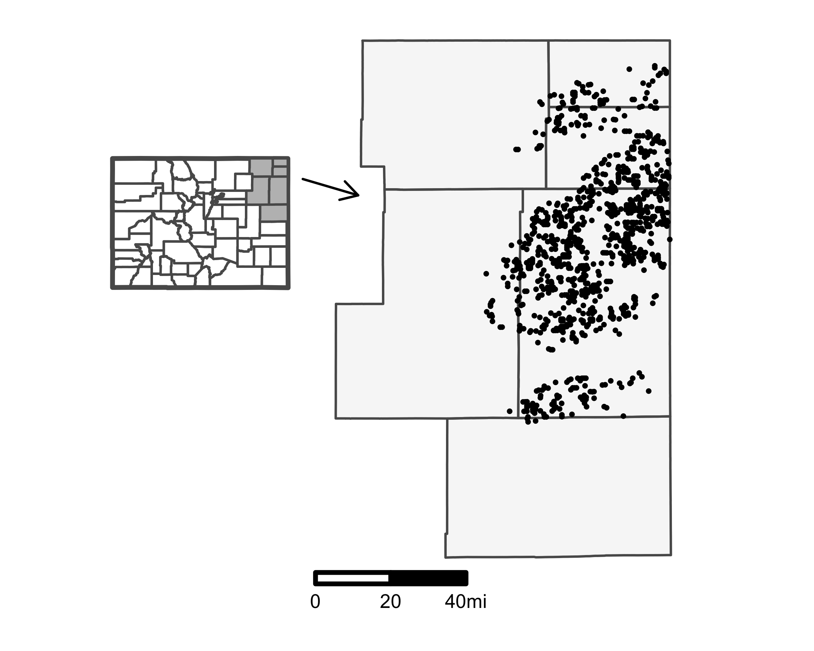

Figure : Spatial Distributions of Wells Used in Empirical Analysis

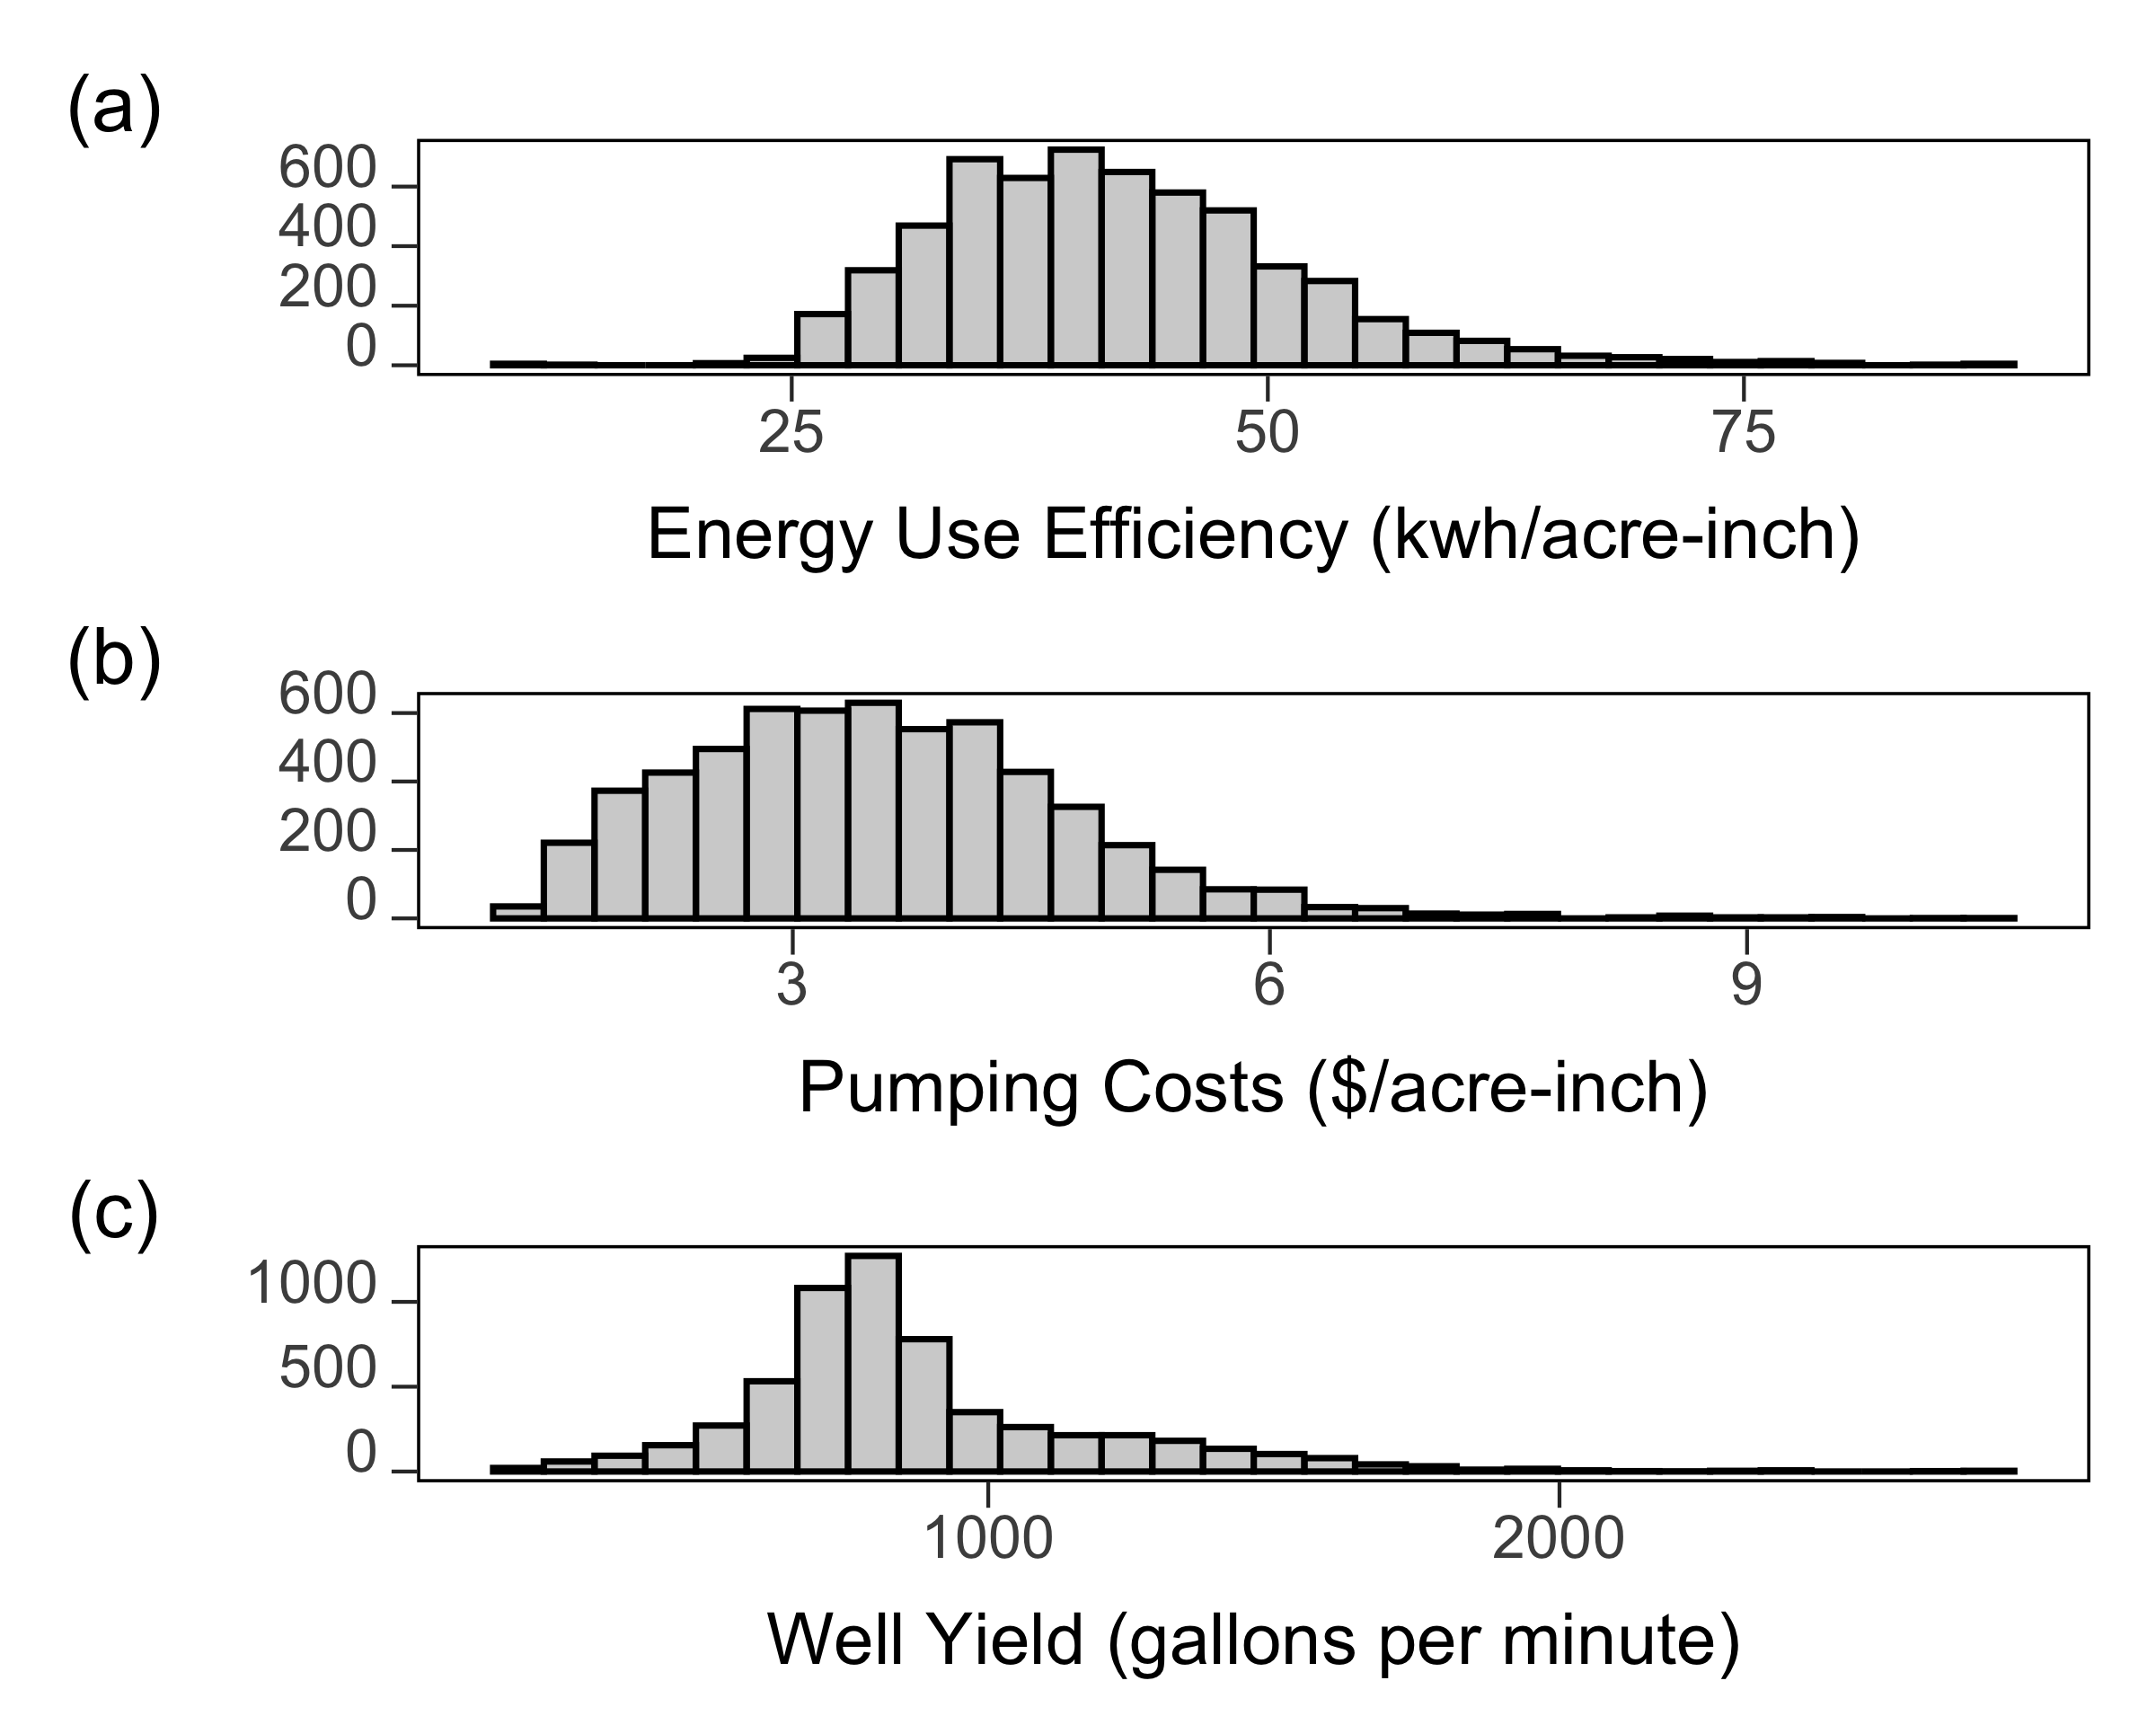

Figure : Heterogeneity of Energy Use Efficiency and Pumping Costs (All Years)

Note: This figure presents the distribution of energy use efficiency, pumping costs, and well yield for all the observed years.

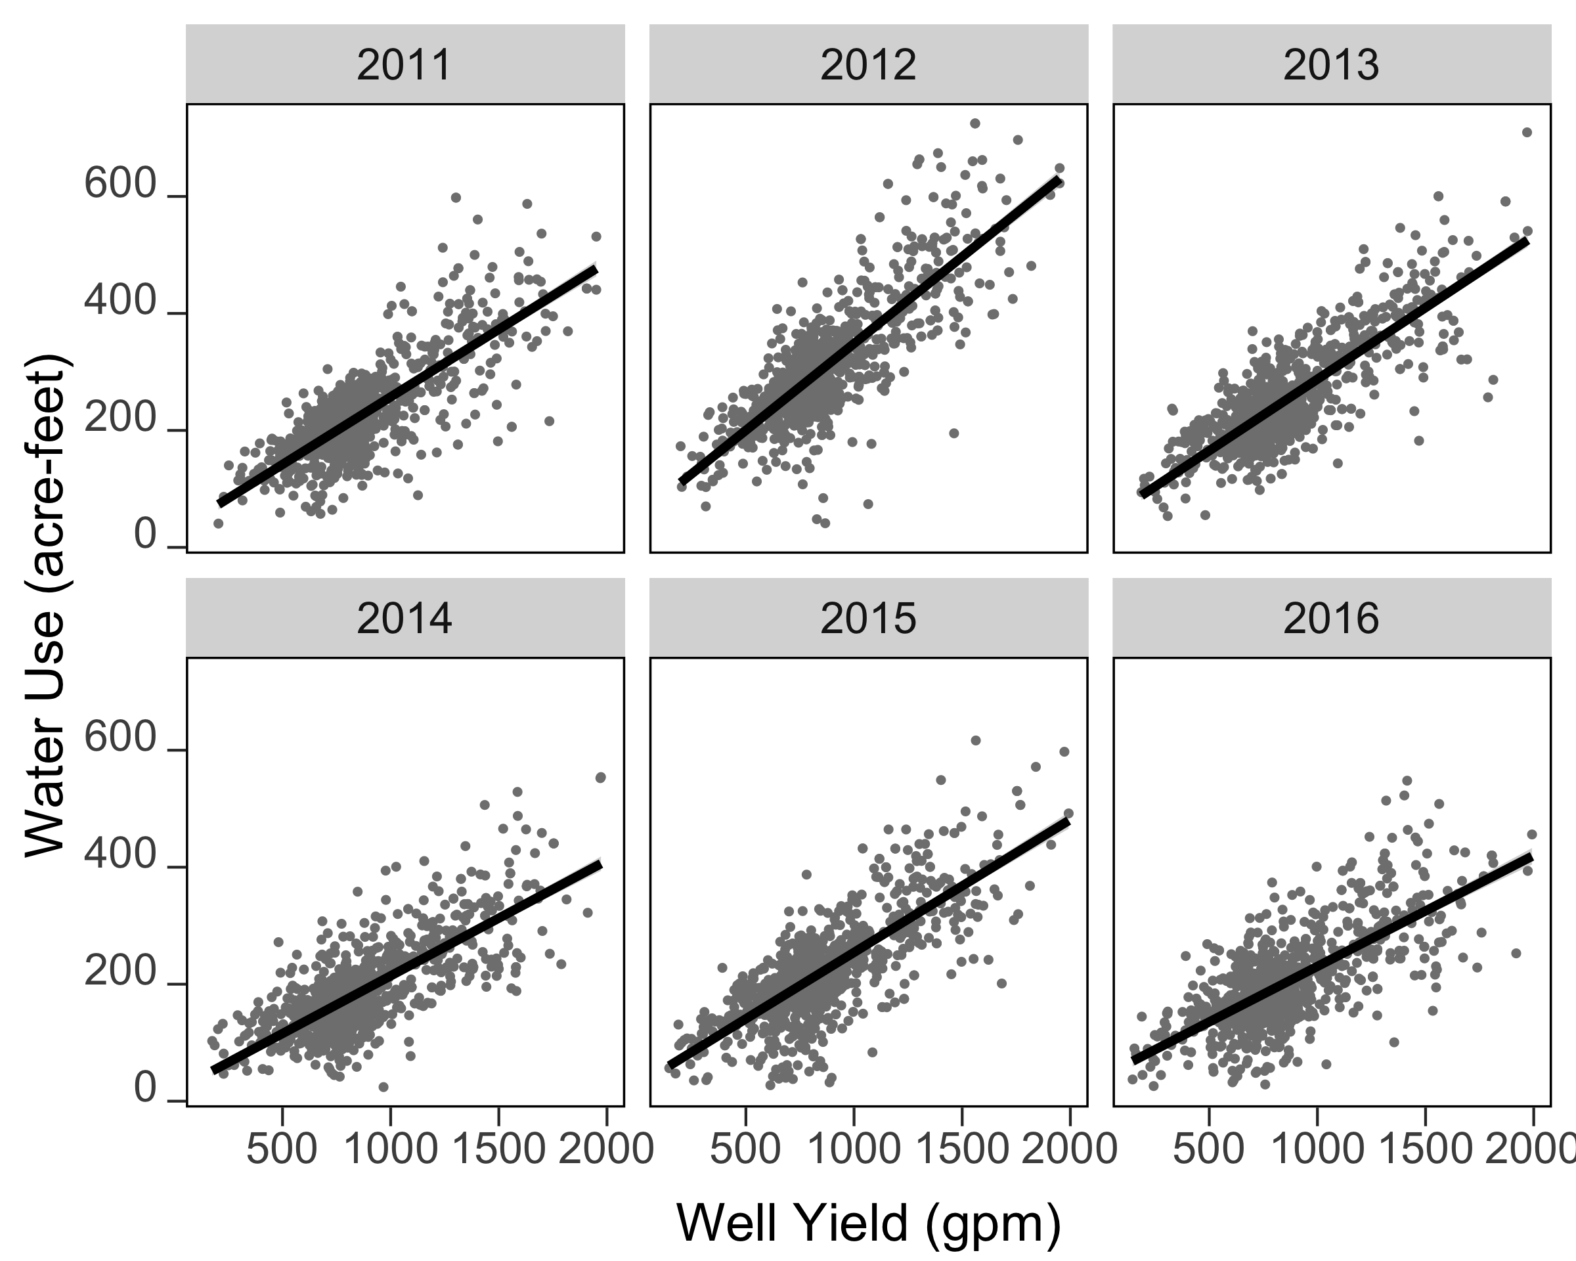

Figure : The relationship between water use and well yield

# Appendix

## Additional Figure

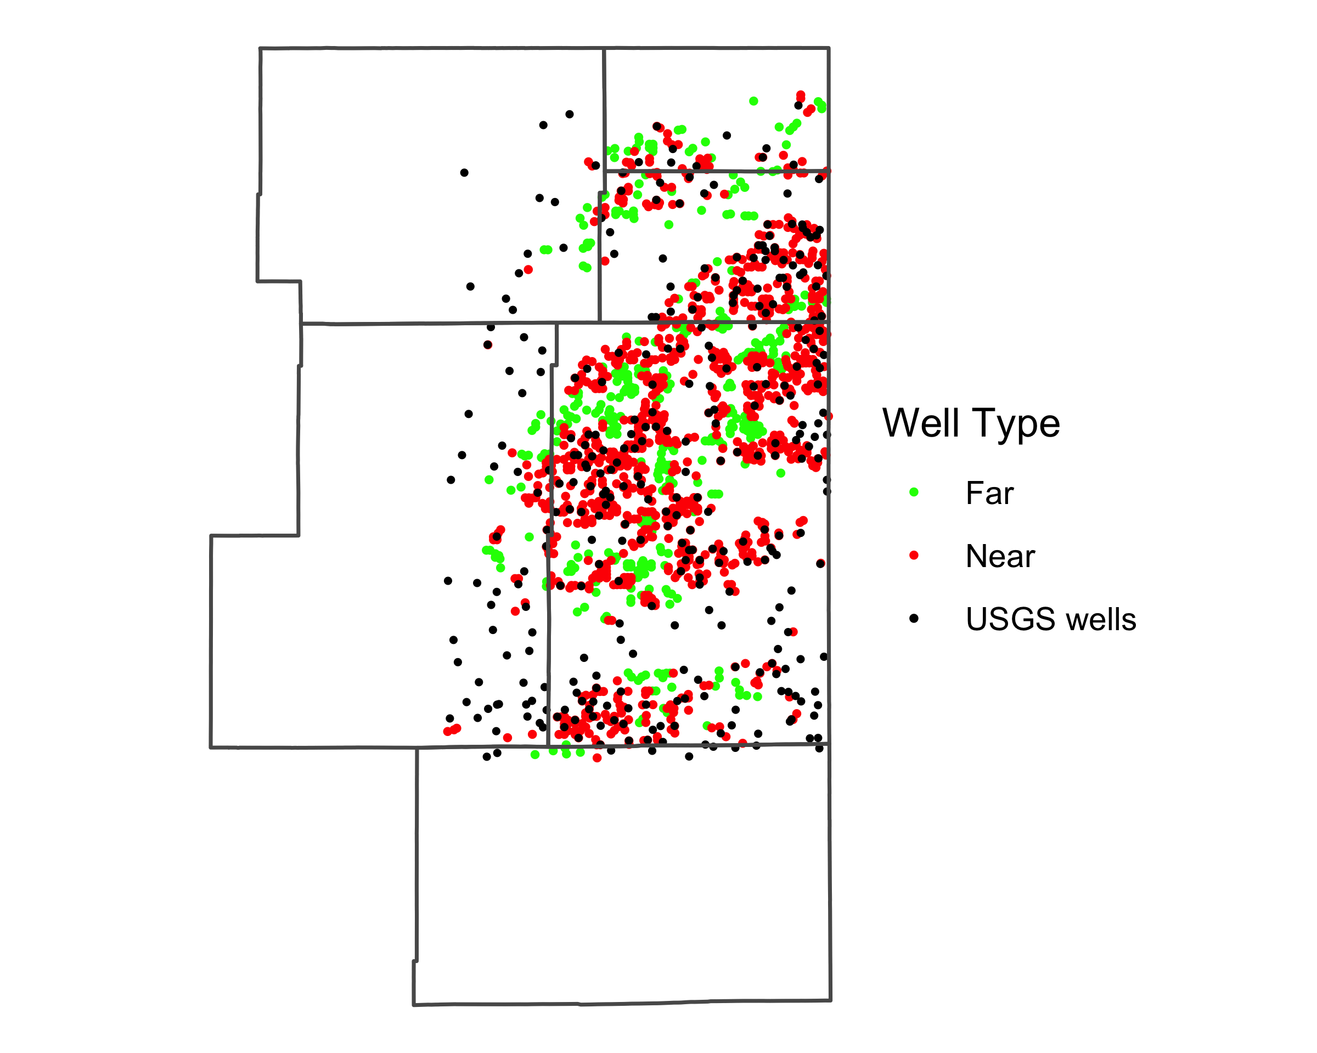

Figure : Irrigation wells that are near and far from USGS monitoring wells

## The Consequence of the Declining Block Rate Pricing Structure for Colorado

Table : The magnitude of potential bias when the endogeneity due to the declining block structure is untreated

|  | Model 1 | Model 2 | Model 3 | Model 4 |
| --- | --- | --- | --- | --- |
| Pumping costs | -44.65*** | -54.19*** | -34.85*** | -51.72*** |
|  | (6.05) | (3.98) | (5.70) | (3.85) |
| Pumping costs (squared) | 3.36*** | 2.76*** | 2.97*** | 2.65*** |
|  | (0.58) | (0.41) | (0.55) | (0.40) |
| Well yield (WY) |  |  | 0.15*** | 0.10*** |
|  |  |  | (0.03) | (0.02) |
| Precipitation (P) | -1.69** | -1.23* | -1.69** | -1.32* |
|  | (0.66) | (0.68) | (0.66) | (0.68) |
| Evapotranspiration | -1.84 | -0.80 | -1.82 | -0.97 |
|  | (1.76) | (1.73) | (1.73) | (1.73) |
| Growing Degree Days | 0.26*** | 0.16* | 0.22*** | 0.09 |
|  | (0.08) | (0.08) | (0.08) | (0.08) |
| Year FEs included? | Yes | Yes | Yes | Yes |
| Well-hp-price tier FEs included? | Yes | No | Yes | No |
| Well FEs included? | No | Yes | No | Yes |
| Num.Obs. | 5916 | 5916 | 5916 | 5916 |
| R2 Adj. | 0.868 | 0.846 | 0.873 | 0.849 |
| (Standard errors are clustered at the well level) | | | | |
| * p < 0.1, ** p < 0.05, *** p < 0.01 | | | | |

Table compares regression results using either well FE or well-hp-price tier FE. While well-hp-price tier FE avoids bias from spurious negative correlation between water use and marginal price due to DBR, well FE does not. Comparing columns 1 (with well-hp-price tier FE) and 2 (with well FE) indicate a significant negative bias due to the DBR structure. Columns 3 and 4 present regression results when well yield is included to the models presented in columns 1 and 2, respectively. The results presented in Column 3 are the main results reported in the paper. Comparing columns 2 and 4 shows that the variation in pumping costs generated by the DBR structure dominates the overall variation in pumping costs and that the inclusion of well yield does not help alleviate the bias.

1. University of Nebraska Lincoln, [tmieno2@unl.edu](mailto:tmieno2@unl.edu)
2. Clemson University, [rrad@clemson.edu](mailto:rrad@clemson.edu)
3. Colorado State University
4. USDA-Economic Research Service, [Aaron.Hrozencik@usda.gov](mailto:Aaron.Hrozencik@usda.gov)
5. In Colorado, pumping cost is equivalent to irrigation cost as groundwater itself is not priced.
6. Rule 12 of State Administrative Rule 2 CCR 402-2, which was implemented in 2009, requires that every groundwater well used for irrigation in the Republican River Basin conduct a well pump test every two or three years depending on the type of test.
7. The sample of wells that we utilize is very similar to the wells that are excluded from the analysis on key variables including water use, well yield, pumping cost efficiency, precipitation, saturated thickness. For example, while the former has 869.92 GPM, the latter has 861.55 GPM
8. kW and HP are both measures of a motors ability to generate work. A 100 HP well has kW of $74.57$ (HP = $0.7457$ kW).
9. This measure is inclusive of all the energy necessary to **apply** water to the field: energy used for pumping and pressurization.
10. 72 out of 964 wells changed horsepower during the period of analysis.
11. Note that the correlation coefficient between the demeaned well yield and pumping costs is the relevant statistic in understanding the omitted variable bias problem in our estimation with well-HP-price tier FE.
12. While Burness and Brill (2001) consider well yield, it only enters their models as a factor that changes pumping costs, but not as a variable to limit farmers’ pumping ability.
13. Aquifer bedrock and surface elevations may have errors. However, please note that their contributions to the identification of the impact of saturated thickness is zero. This is because of the following mathematical relationship of saturated thickness and depth to water table: $\text{saturated thickness}=\text{surface elevation}−\text{bedrock elevation}−\text{depth to water table}$. In calculating saturated thickness, bedrock and surface elevations are assumed to be constant. Therefore, well-HP-price tier FEs eliminate any cross-sectional variation in aquifer geology. Including the negative of depth to water table yields exactly the same regression results. Importantly, this assumption is reliable because the surface and bedrock elevations change very slowly if at all and minimally contribute to changes in saturated thickness over the course of 10 years.